CS571 Spring 2025 – ICA A
Design Thinking
Please make a copy of this document by clicking File > Make a copy. You may share and co-edit it with your fellow group members.

In this in-class activity, you will explore the concept of Design Thinking by seeking to make the college grocery shopping experience better. You will do this by…

- Empathizing with a user’s grocery shopping experience.
- Defining their wants and needs.
- Ideating some crazy, wild ideas.

Areas needing your response are clearly marked with Your Turn! Be sure to complete all aspects of the assignment. Your Canvas submission will be a pdf version of this document.

You may complete this in groups of 1, 2, or 3 people! :) Please be sure to assign yourself and your team member(s) to a group.

1. Empathizing
In class, you observe as a researcher follows and inquires with a college student as they go about their grocery shopping. This is a technique for empathizing with users. With your goal of this research being to make the college grocery shopping experience better (in some regard), make several notes during this video.

Your Turn! Write your notes below. These can be direct quotes, general observations, notes about the environment, or anything else of interest and valuable to your research. You can add additional bullet points if need-be.

- The user goes to the grocery store on a weekly basis, buying the whole week's groceries.
- The user makes a comparison between what he already has and what he is lacking before going to the store.
- The user, as a college student, prefers food that is easy to cook and prepare, like chicken and so on.
- The user prefers the store that is cheaper, but if it lacks his needs he will go to the more expensive one.
- The user prefers physical shopping over online shopping because it helps him to think about the things that he wants to buy, and the walking can be a nice addon to the shopping experience.
- The user prefers the basket over the shopping car for its mobility if he is buying a few things.
- The user gets more frustrated if he is presented with too many brands/options.
- The user’s prior experience of a product can build a trust and comfort relationship with it, making it the next choice to-go when shopping for the second time, even if there are cheaper options.
- The user, as a college student, finds the size of certain products frustrating to consume before the expiry date, resulting in wasting them.
- The user, as a college student, finds the “quick-food” and “snacks” a better option for him because he is busy most of the time in his homeworks and assignments.
- The user prefers the self-checkout because it’s faster than regular checkout.
- The user, most of the time, forgets some items and goes back on a second trip to acquire them.

2. Defining

Next, to better define the problem, you will use affinity diagramming to organize your notes and identify common themes. Specifically, you will identify themes in a bottom-up fashion. That is, you will begin with each of your observations on a sticky note but have no common themes.

As a team, decide which notes are naturally similar to each other. Move the notes that are similar to each other closer together. Quickly, you will begin to identify clusters of notes. When your team agrees that the groups of notes are sufficient, identify a common theme for each of these groups.

To do this, I recommend creating a Google Drawing and representing each sticky note with a square. When you have identified your groups, you may choose to give each theme a color and provide a label over those sticky notes

Your Turn! Paste an image of your affinity diagram below. Additionally, list out the common themes as bullet points below.
- Identify a theme here.
- Identify a theme here.
- Identify a theme here.
- Identify a theme here.

Paste your affinity diagram here.

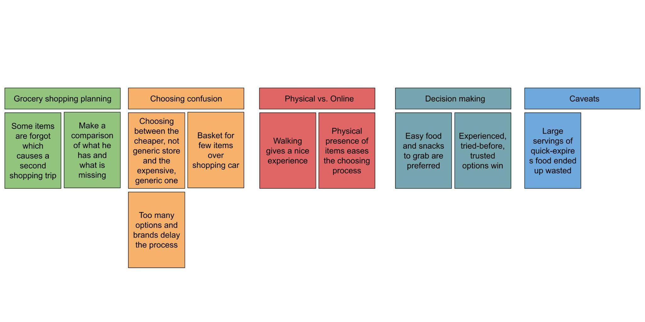

3. Ideating

Then, ideate what a solution could look like. Follow IDEO’s rules of engagement to encourage crazy, wild ideas. In one sentence, briefly describe an idea that could make the college grocery shopping experience better. Think large! Your ideas do not need to strictly be related to software technology.

Your Turn! Describe each of your ideas in one sentence.
- Make a list of needed items before going to shop so you don’t forget some items
- Buying a certain brands for certain things will eliminate the frustration
- Sell some groceries with amounts, e.g. selling milk in liters will allow you to buy the amount you need
- Provide pre-cooked food which only needs heating will allow for more nutritious food

Finally, choose 3 of your top ideas from above and sketch what each of these solutions would look like. You may choose to either hand draw these 3 sketches or to use whichever digital platform you prefer. Reminder: You don’t need to be an artist! A sketch’s purpose is to quickly communicate an idea, not to be put on display at the Chazen!

Your Turn! Paste your 3 sketches here.

After ideating, we would typically begin to prototype, test, and implement. We’ll stop here for the in-class activity; in future lectures we will explore these concepts more deeply! Please be sure to submit this as a PDF to Canvas.
